CEG3156 | Spring 2024



GROUP 10

Laboratory #3: Pipelined Processor

Course Professor: Dr. Rami Abielmona

Name | Student ID
Josue Dazogbo | 300258449
Christopher King | 300226522
Introduction 3
Objectives 3
Main Objective 3
Learned Objectives 3
Prelab 4
Clock Period Calculation 6
Problem and Solution Discussion 6
Instruction Memory 7
Program Counter Logic 7
Register File 8
ALU 8
Datapath 8
Control Path 8
Data Memory 9
Control Logic 10
Buffers 11
Forwarding Unit 12
Hazard Unit 12
Verification 13
RAM 13
ROM 14
ALU 14
Control Path 15
Sign Extension 15
Hazard Detection Unit 15
Forwarding Unit 16
Buffers 16
Top Level Entity 18
Timing Analysis 19
Demo 19
Pin Assignments 19
Board Demo 20
Instruction Execution 21
Bonus 22
Appendix 22
Prelab Detailed Equations : 22
Hand calculations 23

Introduction
The purpose of this lab is to design, implement, and test a pipelined RISC style processor using the MIPS instruction set. This processor has been designed using the data paths and control logic provided in the lab manual and throughout the class. The processor will be tested using an example program seen in the appendix. This lab will strengthen and solidify understanding of single cycle processors and the MIPS architecture.

Objectives

Main Objective
The primary objective of this laboratory is to design and build a data pipeline RISC-type processor in VHDL. This involves understanding the architecture and functionality of a RISC processor, implementing the necessary hardware components, and verifying their functionality through simulation and physical implementation on an FPGA board.

Learned Objectives
Throughout the course of this lab, the following objectives were achieved:
- Design and Implementation of a Multi-Cycle Data Pipelined RISC Processor: Designed, realized, and tested a pipeline RISC processor, gaining hands-on experience with RISC architecture and instruction set architectures.
- Understanding of MIPS Instruction Formats: Developed a comprehensive understanding of MIPS instruction formats, including R-type, I-type, and J-type instructions, and their roles in processor operations.
- VHDL Coding and Simulation: Practiced writing VHDL code at the structural level, ensuring a deeper understanding of Register Transfer Logic (RTL) design. Simulated designs to verify correctness against theoretical expectations.
- FPGA Implementation and Testing: Implemented the processor design on a Cyclone FPGA board, using DIP switches to input values and LEDs to display the output. This provided practical experience with hardware design and debugging.
- Problem-Solving and Troubleshooting: Enhanced problem-solving and troubleshooting skills through the process of design, simulation, and physical testing, learning how to overcome various design obstacles.
- Efficiency Calculation: Calculated the CPU execution time and maximum clock frequency of the processor, providing an understanding of performance metrics for pipeline processors.
By completing these tasks, we not only met the main objective of the lab but also gained valuable skills and knowledge that will be applicable in future digital logic and computer systems design projects.

Prelab
For the pre-lab of Laboratory #3, we designed the Hazard Detection and Forwarding Units to identify and resolve data hazards in the pipeline. The Hazard Detection Unit identifies dependencies between instructions, ensuring proper handling of these hazards. The Forwarding Unit resolves data hazards by forwarding needed data from later stages back to earlier stages, preventing pipeline stalls. Detailed designs include truth tables and Boolean realizations to optimize the circuits. Analyzing a sample scenario demonstrates the correct operation of these units, showing how they resolve hazards to maintain pipeline functionality. We presented and explained these designs and their operations to the Teaching Assistant, and a picture of the completed designs is shown below. Logic equations and detailed design can be found in the appendix.
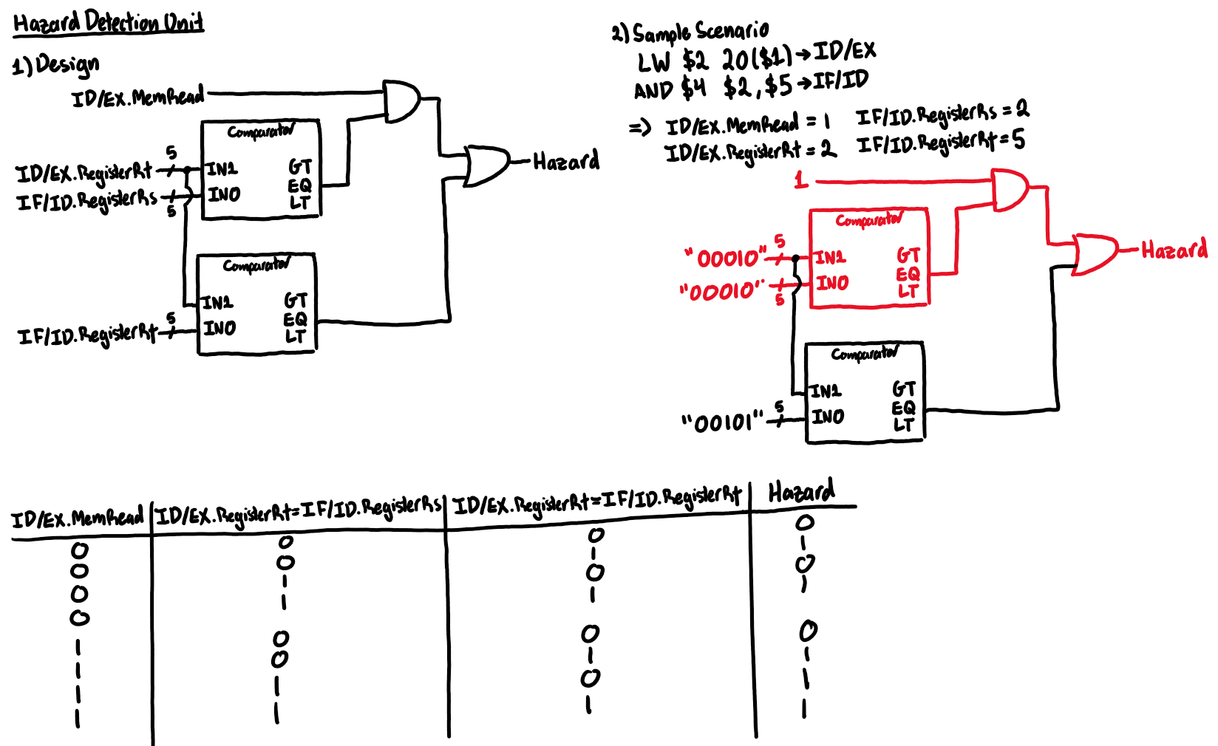
Figure 1: Hazard Detection Unit Design and Sample Execution
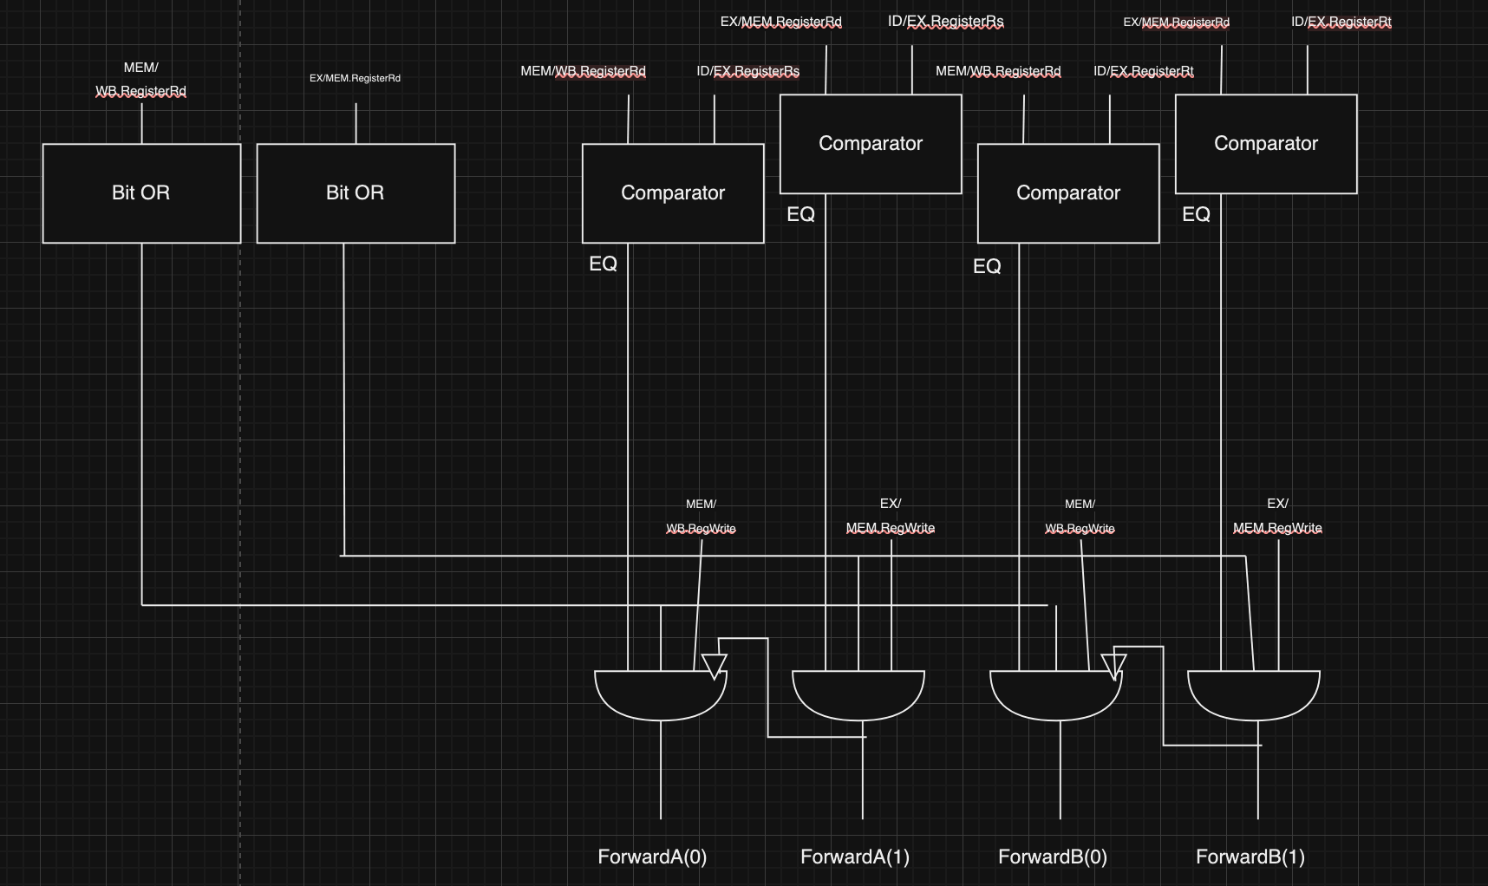

Clock Period Calculation
Calculating the clock period for a digital system, such as a processor, involves determining the maximum time required for the longest path (also known as the critical path) between two sequential elements in the circuit. This critical path includes the propagation delays through logic gates and interconnects, as well as setup and hold times for registers. The clock period must be greater than or equal to the sum of these delays to ensure correct timing and data integrity. Our ALU design is predicted to have 53 separate gates in the critical path length mostly because of our 32 bit ripple carry adder circuit. We ignore the very short delay introduced by multiplexers since they only contain 2-3 gates in their critical path length. Adding up all the times from the lab manual, we can generate this table for each instruction. Here is the computation for the longest instruction.
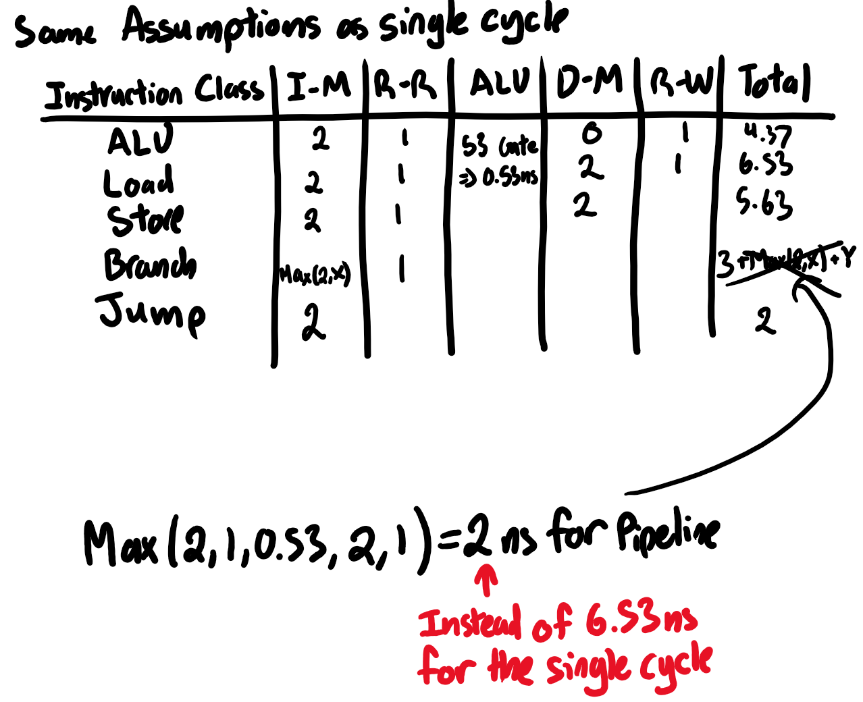
Figure 2: Theoretical Clock Frequency Computation

Problem and Solution Discussion
In this laboratory, the task is to design and implement a single cycle MIPS processor using VHDL. This requires the design of the data path and control path separately. The data path was designed using existing diagrams of the MIPS processor provided in the lab manual with modified bus widths. The word size of this processor is 8 bits while supporting a 32-bit instruction. This requires the registers, ALU, and data memory to be adjusted to support the 8-bit word.
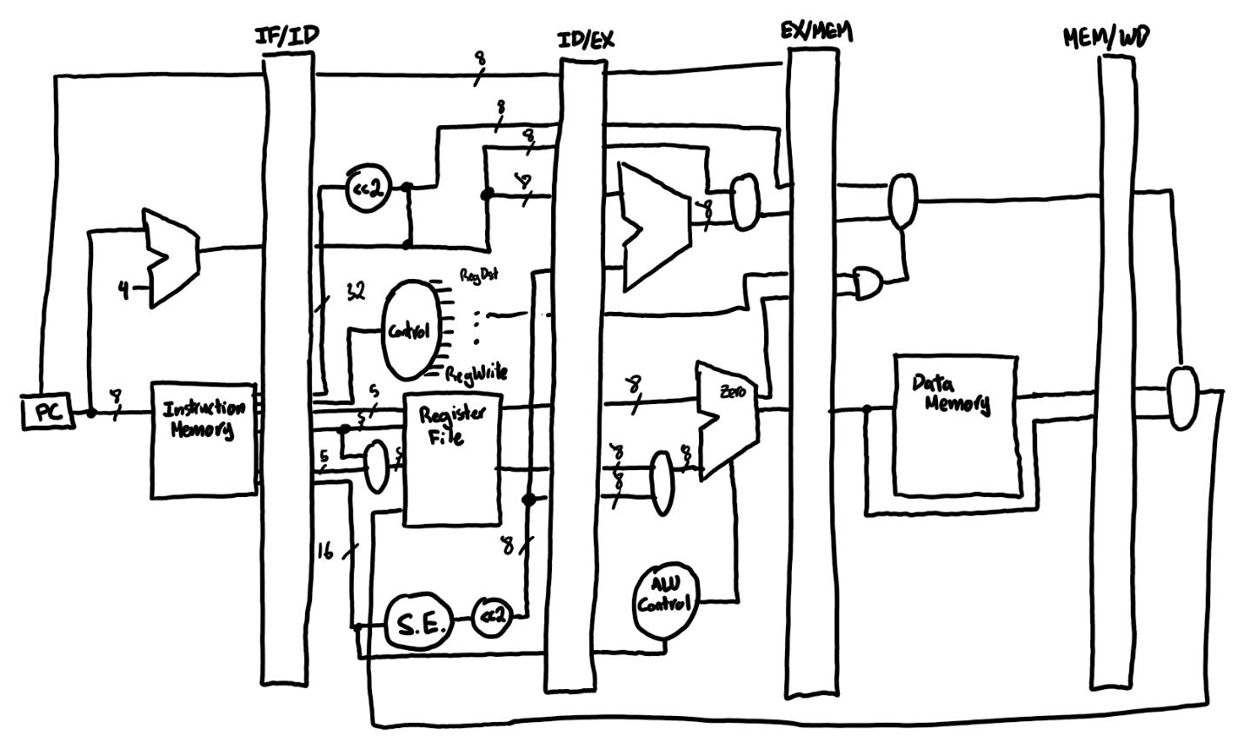
Figure 3: Top Level Data Path

Instruction Memory
The processors instruction memory is a 32-bit word with 8 address lines. This allows the processor to address 256 unique instructions. This was implemented using a pre-build Altera LPM component LPM_ROM. This component allows data to be programmed in Quartus using an MIF file and to be read in simulations and using the FPGA. This component was then used in a VHDL wrapper to simulate the ROM and verify functionality.

Program Counter Logic
As specified in the lab manual, the processor has access to 256x32 of instruction memory. This means the instruction memory has 8 address bits and therefore the program counter has 8 bits. The program counter has 3 possible loads. Under normal operation (no branch or jump) the PC is simply incremented.
When executing a branch instruction, the branch target address is calculated by a separate ALU that adds current program counter with the offset. The main ALU then compares the value of the 2 registers and controls the mux to either load the BTA or the incremented PC (if the branch is not taken).
When executing a jump instruction, the address is loaded into the jump mux and the control unit asserts the jump signal to select the jump address instead of the regular incremented PC.

Register File
The register file (RF) consists of 8 registers of 8 bits each. The RF has 2 read ports and 1 write port that can all be accessed within a single cycle. Each port has a 3-bit register select input. These 3 bits control an output multiplexer for the read ports and are used to assert a write signal to a register for the write ports using a decoder.

ALU

Datapath
The ALU consists of the ALU data path and the ALU control unit. The ALU data path consists of an 8-bit adder for addition and subtraction operations as well as logic gates for OR and AND. The ALU output is controlled by an 8-bit multiplexer to select between the different operations.
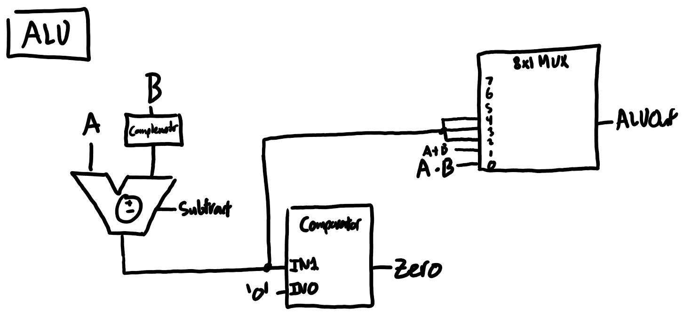
Figure 4. High level ALU data path

Control Path
The ALU operation is controlled by both the op code of the executing instruction and a function code. R-type instructions specify ALU operation with a function code while other instructions may need to use the ALU for other purposes (such as calculating an effective address). The control logic was designed using the following truth table.
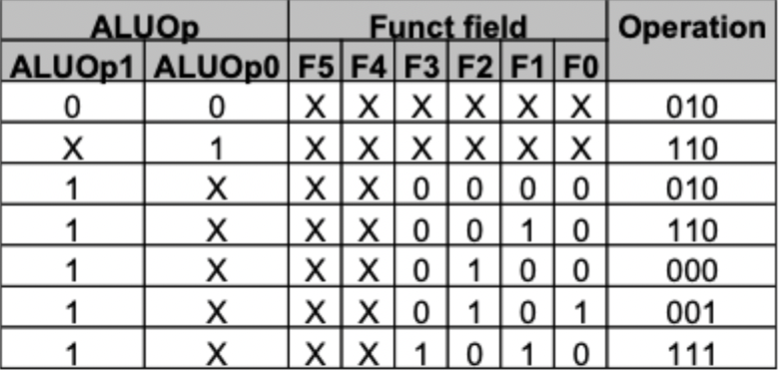
Figure 5. ALU Control Operations
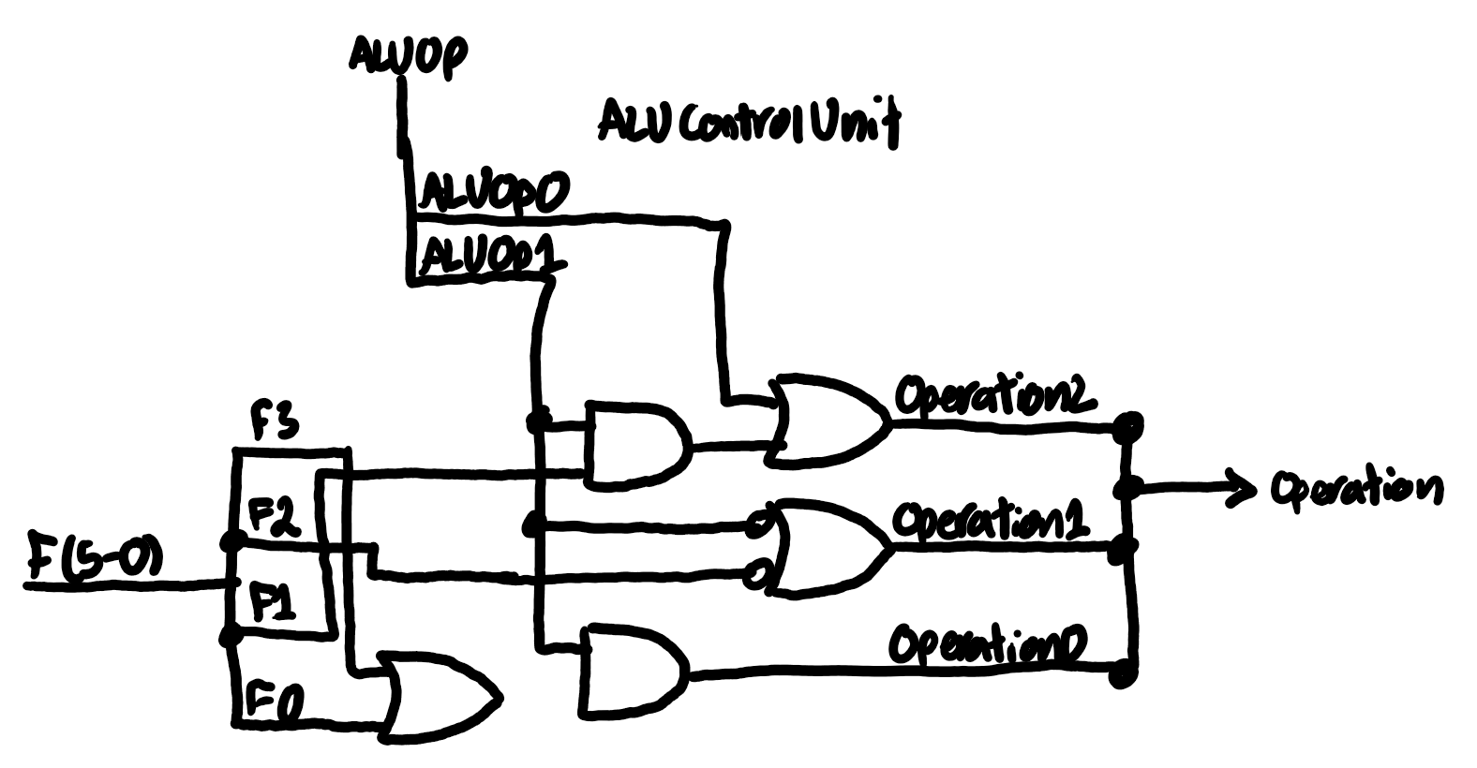
Figure 6. ALU Control Unit

Data Memory
The processors data memory is an 8-bit word with 8 address lines. This allows the processor to address 256 unique words in ram. This was implemented using a pre-build Altera LPM component LPM_RAM_DQ. This component allows data to be programmed in Quartus using an MIF file and to be read and written in simulations and using the FPGA. This component was then used in a VHDL wrapper to simulate the RAM and verify functionality.

Control Logic
The control path was designed according to the following table and flow chart shown in figure 4. These diagrams were then used to create a gate level implementation shown in figure 5.
Instruction | RegDst | ALUSrc | Mem-to-Reg | Reg Write | Mem Read | Mem Write | Branch | ALUOp1 | ALUOp0
R-format | 1 | 0 | 0 | 1 | 0 | 0 | 0 | 1 | 0
lw | 0 | 1 | 1 | 1 | 1 | 0 | 0 | 0 | 0
sw | X | 1 | X | 0 | 0 | 1 | 0 | 0 | 0
beq | X | 0 | X | 0 | 0 | 0 | 1 | 0 | 1
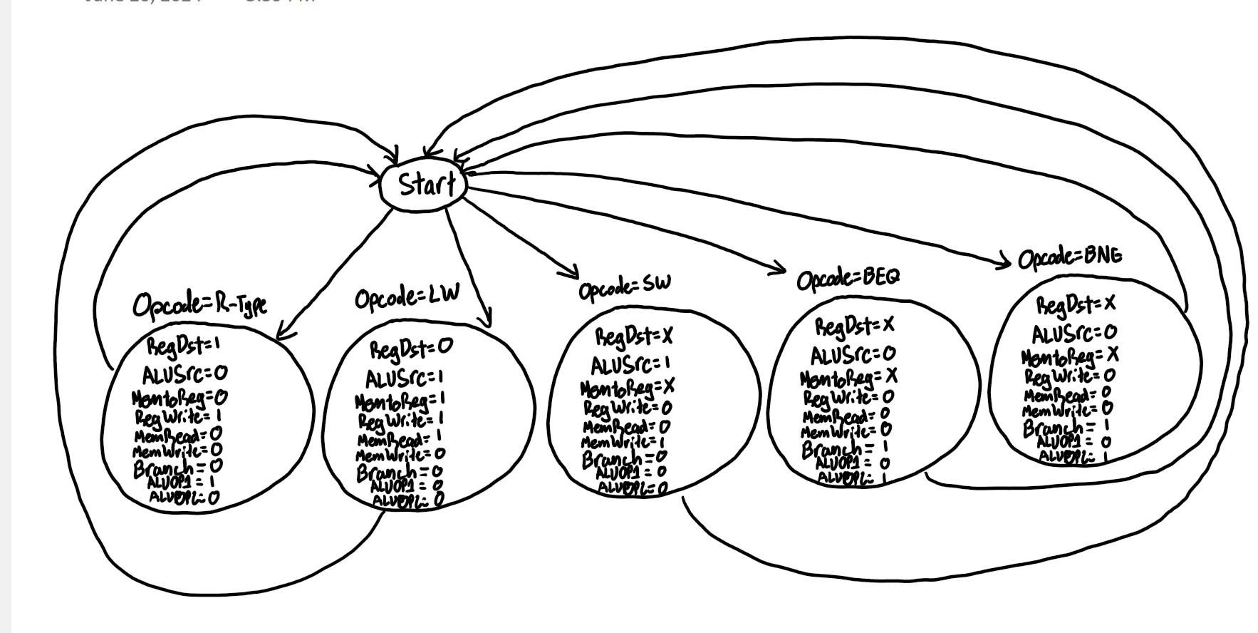
Figure 7. Control logic flow chart
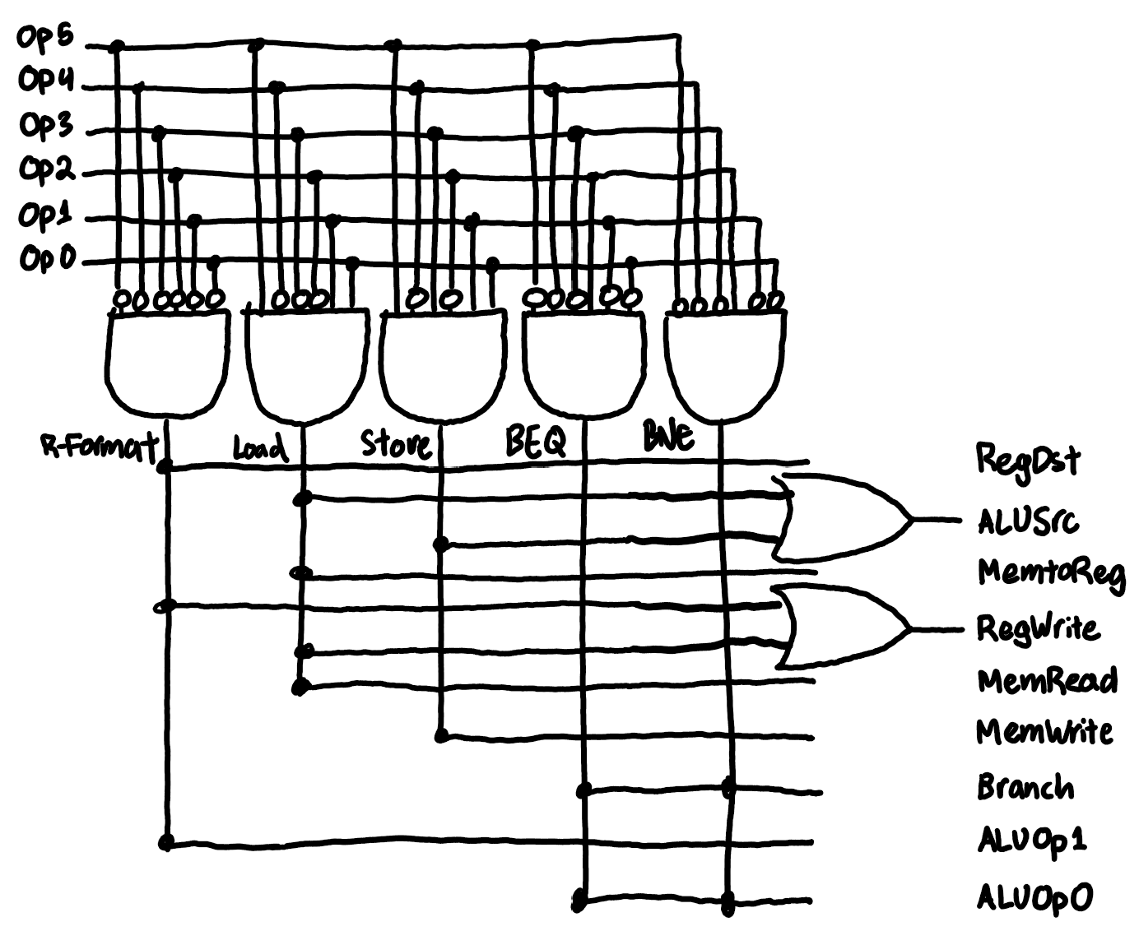
Figure 8. Gate level control logic

Buffers
The general architecture of the buffers in the lab is designed to manage and synchronize data flow between different pipeline stages of the CPU, ensuring efficient and accurate instruction processing. Each buffer, or pipeline register, holds specific data that is passed from one stage to the next at each clock cycle. The IF/ID buffer captures the instruction and program counter from the Instruction Fetch stage and passes them to the Instruction Decode stage, allowing for parallel fetching of the next instruction. The ID/EX buffer receives decoded instruction details such as control signals, register values, and immediate values, and passes them to the Execution stage, enabling the ALU operations. The EX/MEM buffer holds the results of the Execution stage, including ALU results and destination registers, and forwards them to the Memory stage for potential memory operations. Finally, the MEM/WB buffer captures the data from the Memory stage or the ALU results and writes it back to the appropriate register in the Write Back stage, completing the instruction cycle. Each buffer ensures the seamless and synchronized progression of instructions through the CPU pipeline, enhancing overall performance and efficiency.

Forwarding Unit
The Forwarding Unit is designed to resolve data hazards in a pipelined CPU by forwarding data from later stages to earlier stages. It takes the register addresses from the MEM/WB and EX/MEM stages (i_MEM_WB_Rd and i_EX_MEM_Rd), and compares them to the register addresses in the ID/EX stage (i_ID_EX_Rs and i_ID_EX_Rt) using eight-bit comparators. These comparators check if the register addresses match and if the corresponding register write signals (i_MEM_WB_RegWrite and i_EX_MEM_RegWrite) are active. Based on these comparisons, the unit generates forwarding signals (o_ForwardA and o_ForwardB) that determine whether to forward data from the MEM/WB or EX/MEM stages to the ID/EX stage. This ensures that the correct data is available in the pipeline, preventing stalls and maintaining efficient instruction execution. The design utilizes internal signals and logic to handle the forwarding conditions, ensuring proper data flow between stages. The detailed architecture and the resulting forwarding decisions are illustrated and analyzed in the completed designs shown below.

Hazard Unit
The Hazard Detection Unit is designed to identify data hazards in a pipelined CPU, specifically load-use hazards. It monitors the ID/EX pipeline stage to determine if a memory read operation (ID_EX_MemRead) is active and compares the destination register (ID_EX_RegisterRt) with the source registers of the subsequent instruction in the IF/ID stage (IF_ID_RegisterRs and IF_ID_RegisterRt). By using eight-bit comparators, the unit converts the three-bit register addresses to eight-bit signals for accurate comparison. The comparators check if the destination register from the ID/EX stage matches either of the source registers in the IF/ID stage, generating signals (RtRs_Equal and RtRt_Equal) to indicate equality. If a match is found and a memory read is active, the unit sets the Hazard_Detected signal to indicate the presence of a hazard, allowing the pipeline to stall and prevent incorrect data propagation. This detailed detection process ensures the CPU can handle data hazards efficiently, and the completed design is illustrated below for further clarification.
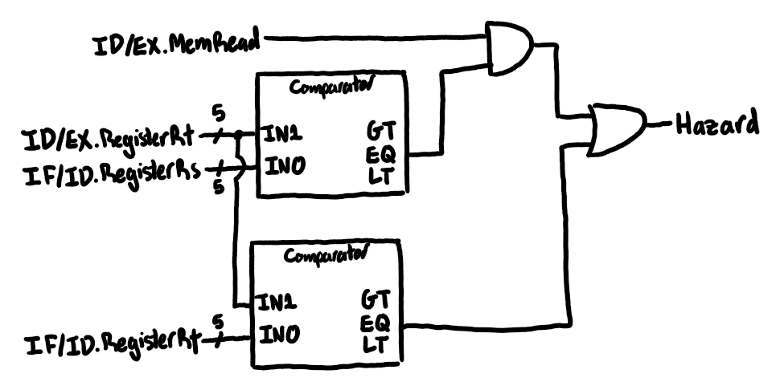
Figure 9: Hazard Detection Unit Logic Gate Design
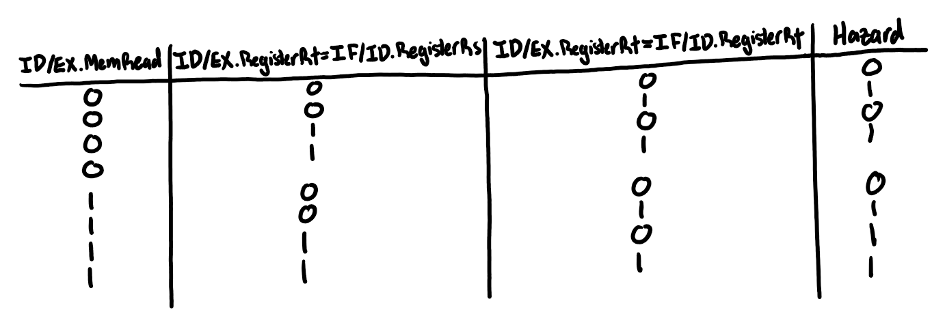
Figure 10: Hazard Unit Boolean Table

Verification

ALU
Simulation of the ALU was performed by asserting 2 values on the inputs and changing the operation input to test different operations. Separate inputs were used to check the ALU overflow flag as shown in the image. The simulation was completed successfully with results as expected.

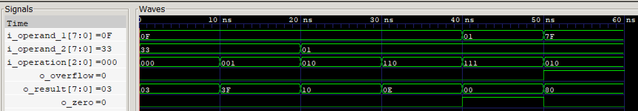
Figure 13. ALU Simulation

Control Path
Simulation of the control path was performed by testing the 4 different op codes from the 4 different instructions and ensuring the asserted control signals matched the table in the design. The simulation was completed successfully with results as expected.
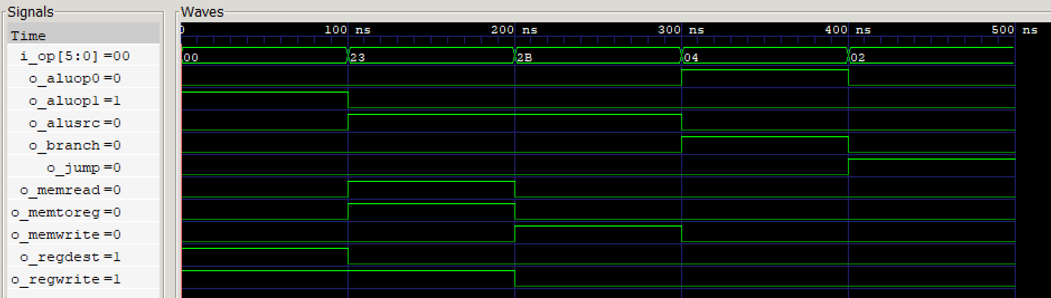
Figure 14. CPU Control Path Simulation

Sign Extension
Simulation of the sign extension unit was performed by testing a positive and negative number. When a positive number is received the sign extender should fill the “extended” bits with zeros and when a negative number is received the sign extender should fill the “extended” bits with ones. The simulation was completed successfully with results as expected.
Figure 15. Sign Extend Module

Hazard Detection Unit
The HazardDetectionUnitTestBench verifies the functionality of the Hazard Detection Unit by simulating different scenarios. It sets up initial conditions, instantiates the unit under test, and applies various test cases to ensure the unit detects hazards correctly.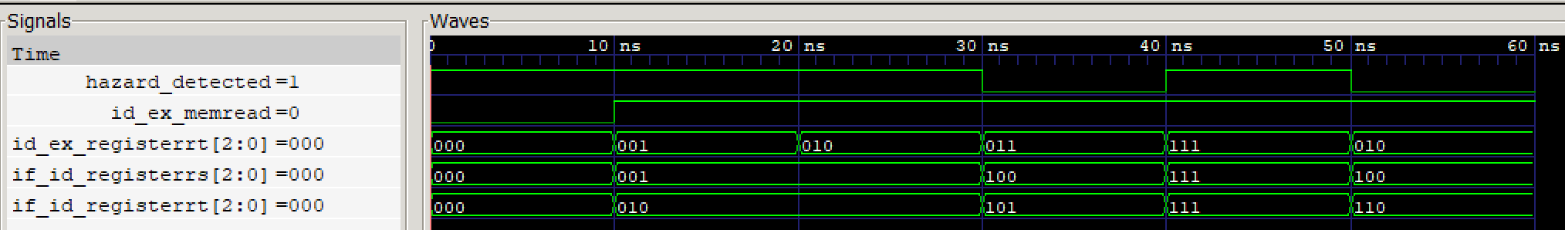

Forwarding Unit
To simulate the Forwarding Unit, we created a test bench that instantiated the Forwarding Unit and applied various test cases to verify its behavior. We defined input signals and applied different scenarios, such as no forwarding, forwarding from MEM/WB to Rs or Rt, and forwarding from EX/MEM to Rs or Rt, observing the outputs to ensure correct operation.
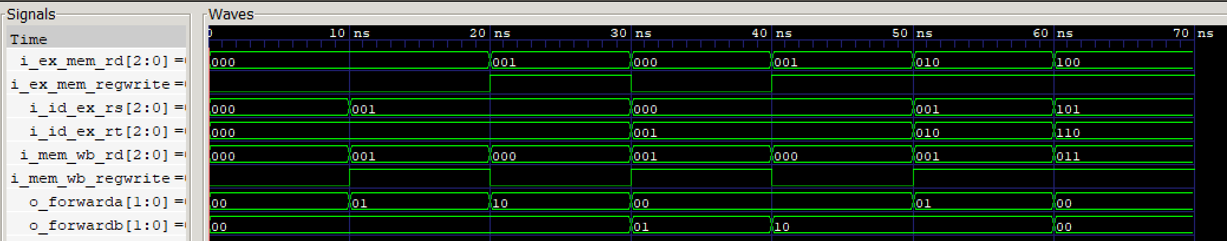

Buffers
In the simulation of the buffers, we created a testbench to verify the functionality of each buffer component. This involved instantiating the buffer in a VHDL testbench and applying a series of test cases with different input signals to observe and verify the output responses, ensuring the buffers performed as expected under various conditions.
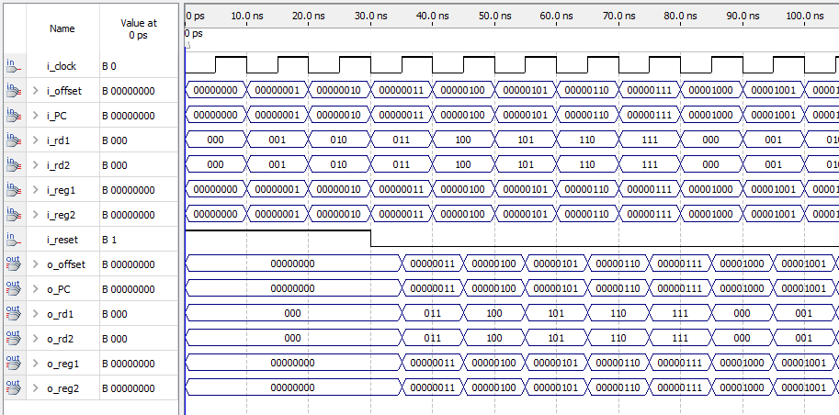
Figure 16: Working Simulation of a Pipeline Buffer, IF/ID in this Case

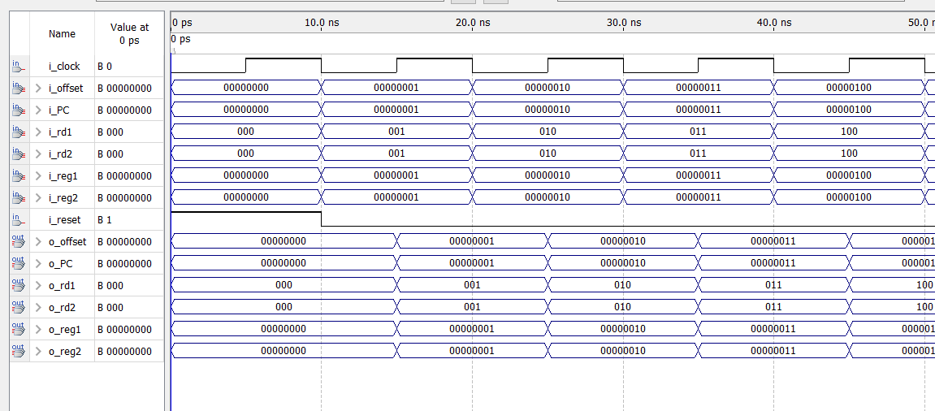
Figure 17: Working Simulation for ID/EX

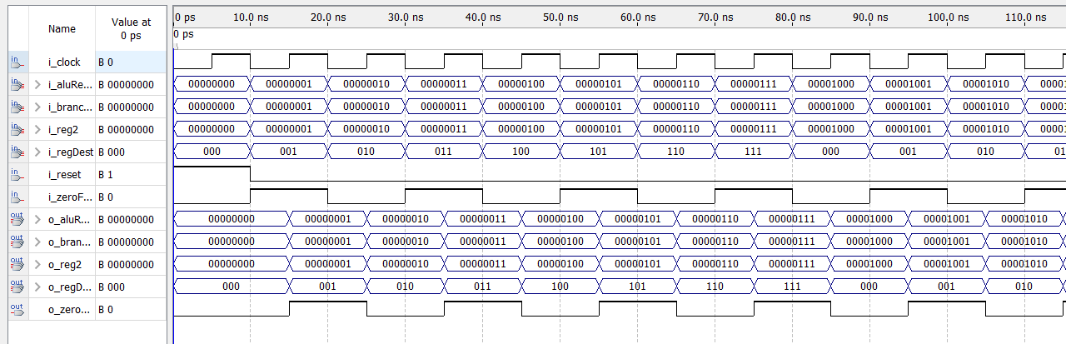
Figure 18: Working Simulation of EX/MEM
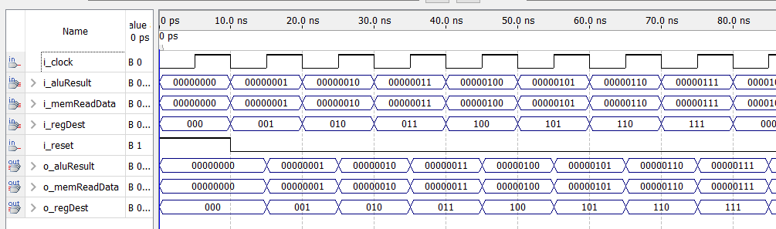
Figure 19: Working Simulation of EX/WB

Top Level Entity
The Top level entity of this design is simulated below. We have added extra signals for debugging purposes.
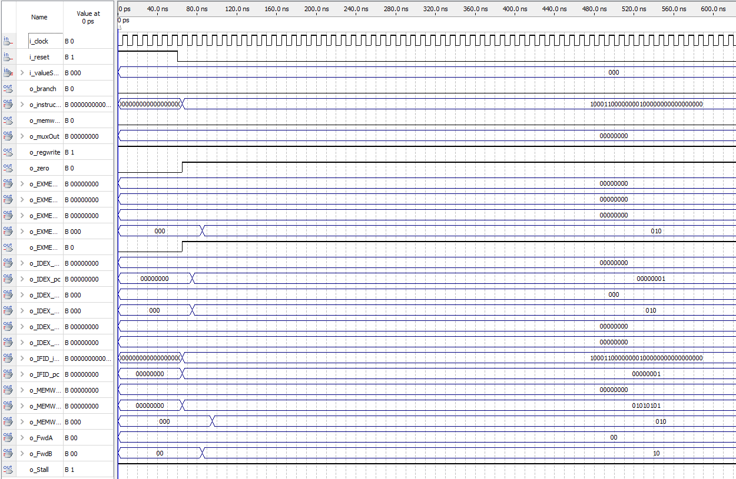
Figure 20: Pipeline processor software execution simulation
As we can see from the simulation, the processor seems to block at the instruction “10001100000010000000000000000000”. We believe this is caused by the stall that occurs when the hazard is detect but doesn’t seem to disappear. This causes the cpu to stall infinitely which implies something is wrong with the connection between the hazard detection unit, the forwarding unit and the cpu.

Timing Analysis
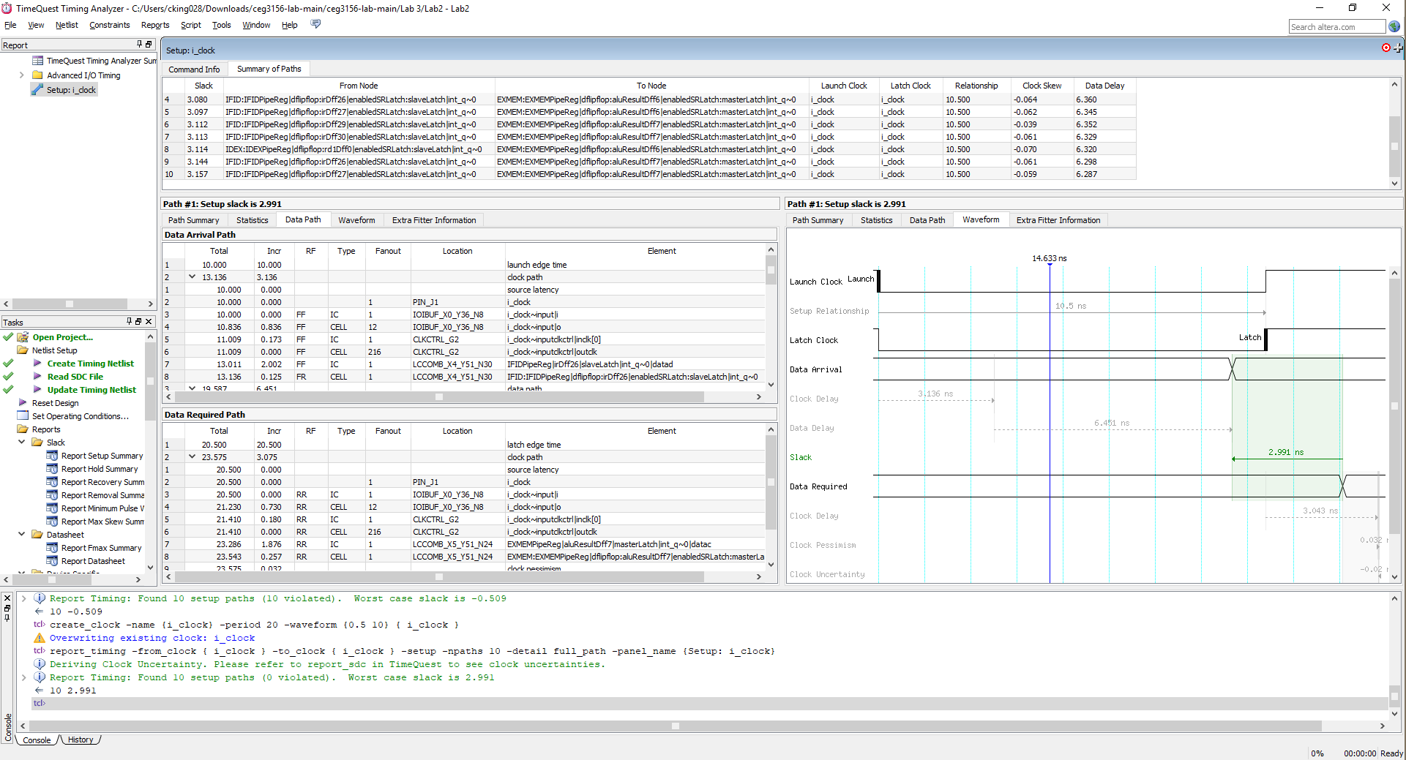
Figure 21: Quartus Timing Tool

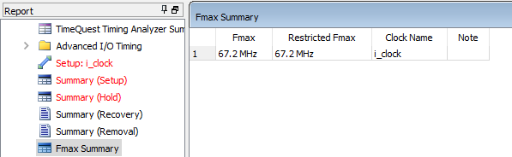
Figure 22: Maximum Clock Frequency computed by the TimeQuest

Demo

Pin Assignments
We were successfully able to load the project onto the Altera-Board. Here is the appropriate PIN assignment to display the instruction on the board.
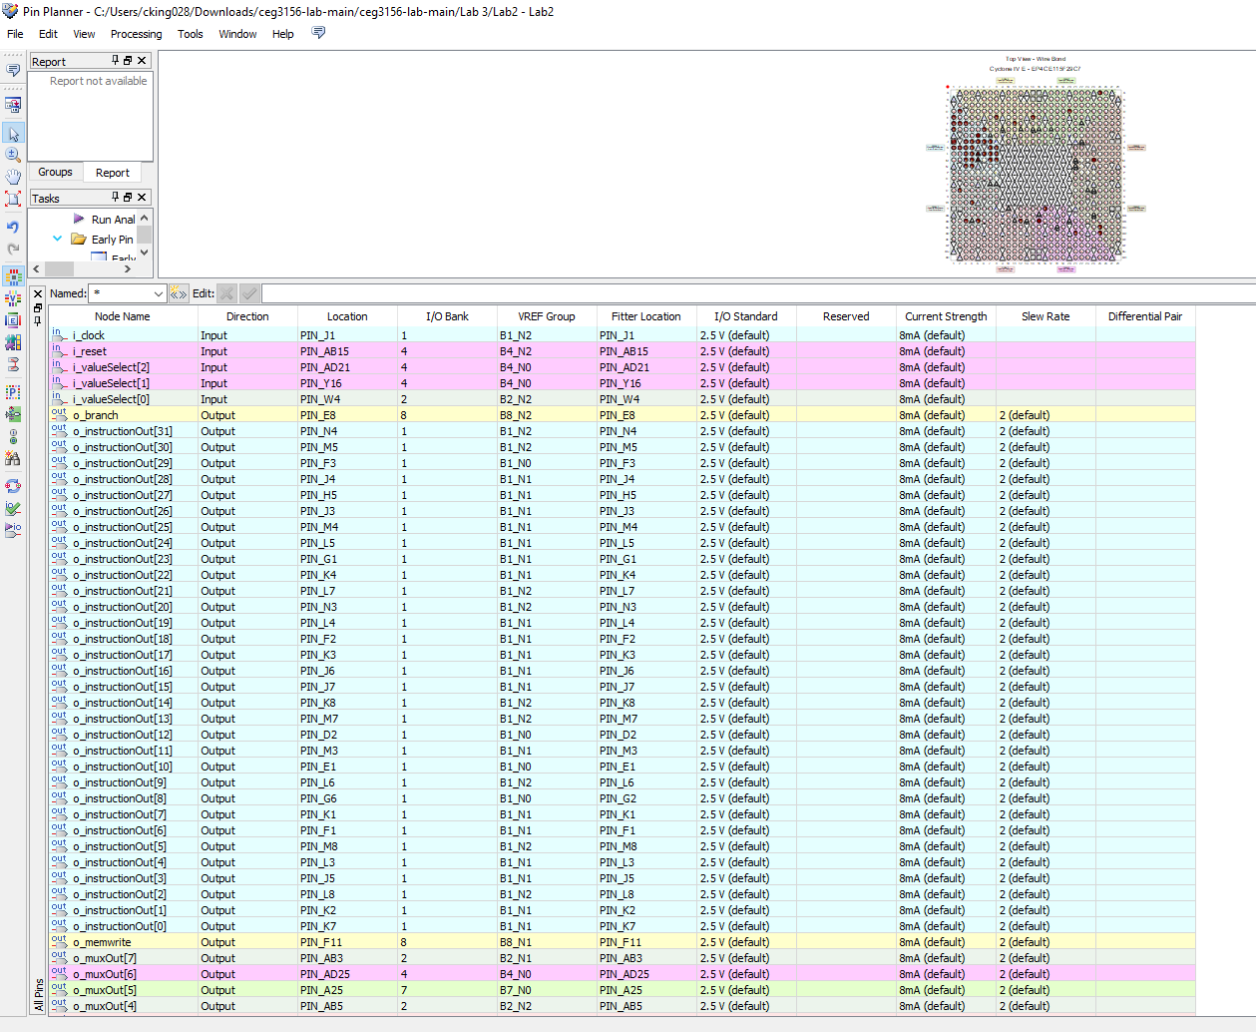
Figure 23: Processor pin assignments

Board Demo
After pin assignments were completed successfully, an attempt was made to run the project on the Altera DE2 board. Similar to the simulations. We noticed that the processor is stuck on a single instruction and will not continue due to the hazard detection unit causing a stall. Since the hazard detection unit was simulated successfully it is likely the issue is a connection within the processor to the hazard detection unit.
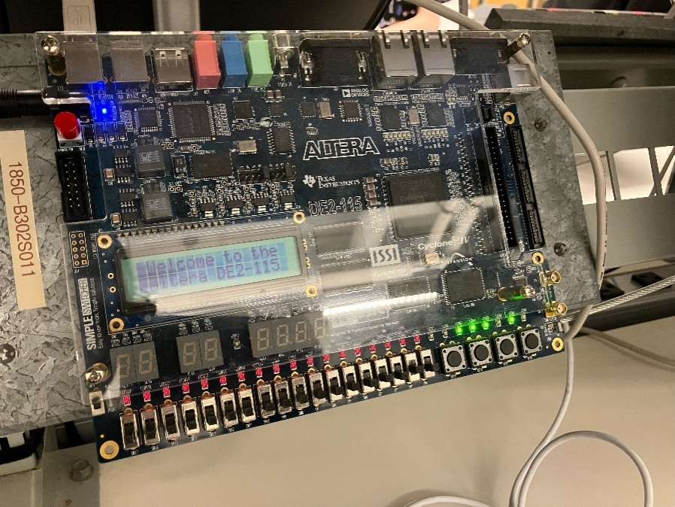
Figure 24: Software loaded on the board

Instruction Execution
Figure 25 shows the execution of the benchmark program for testing. Data hazards are indicated by underlining registers in different colors and “…” indicating stalls in the pipeline.
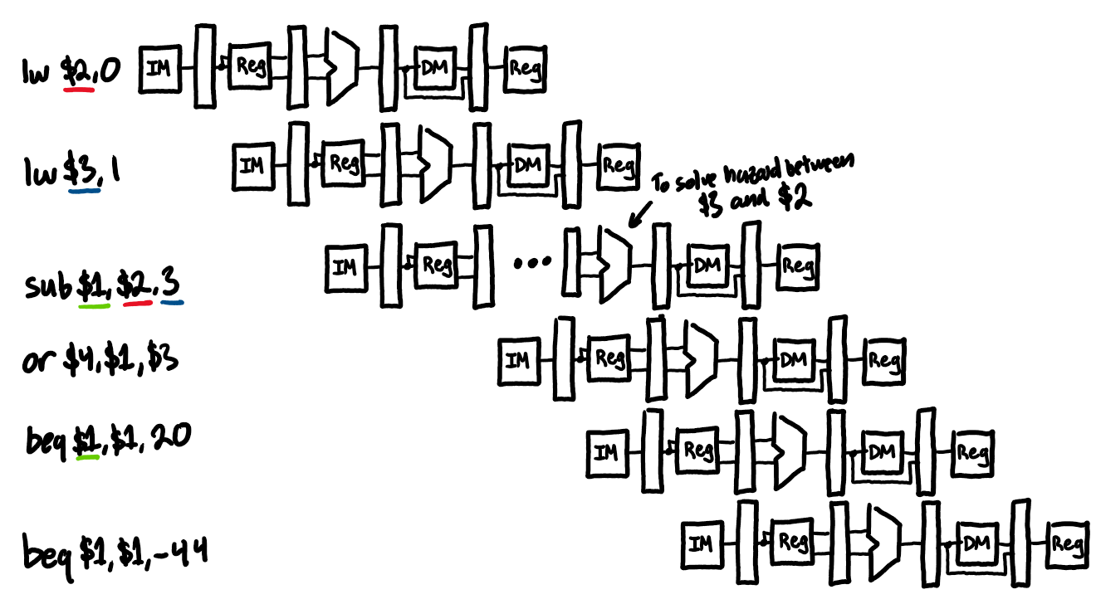
Figure 25: Instruction Execution Simulation

Bonus
A 32 bit data path can be created quite eaisily by modifying the 8 bit datapath. This requires that all registers, the ALU, and sign extend units must be modified to support 32 bit words. Furthermore, the instruction and data memory could be modified to support 32 bit addresses allowing for significantly longer programs and data. This would also require the program counter and accompnying logic such as BTA calculations support 32 bit words.
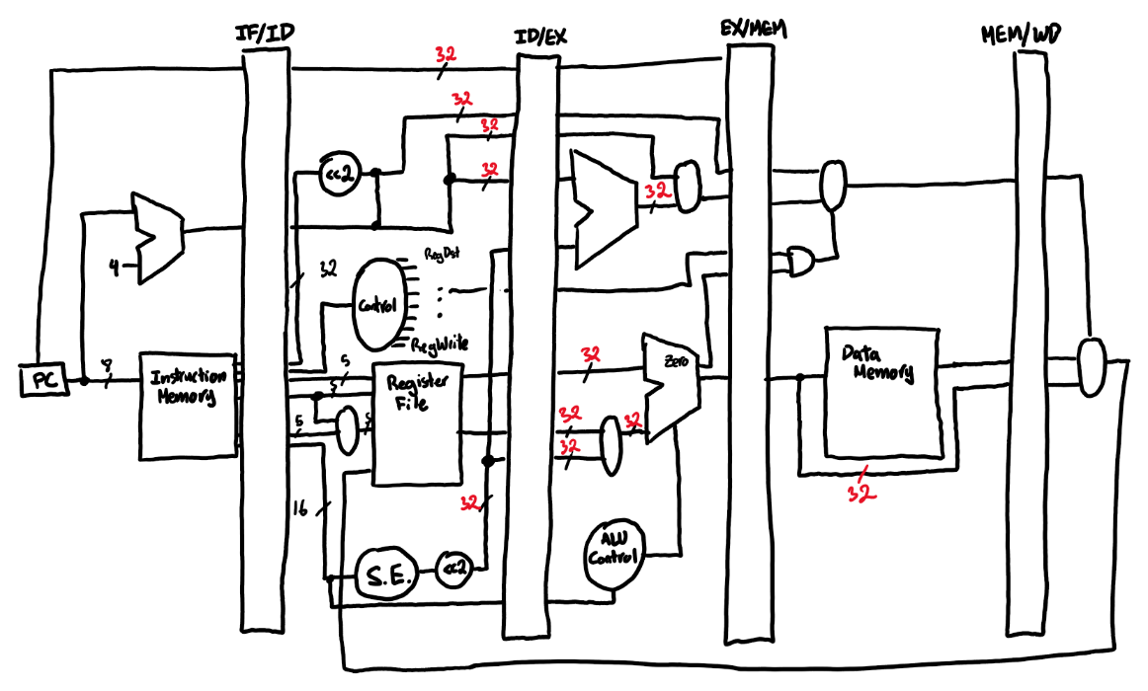
Figure 26: 32 Bit Pipeline DataPath

Appendix

Prelab Detailed Equations
- EX/MEM.RegisterRd = ID/EX.RegisterRs
- EX/MEM.RegisterRd = ID/EX.RegisterRt
- MEM/WB.RegisterRd = ID/EX.RegisterRs
- MEM/WB.RegisterRd = ID/EX.RegisterRt
We do NOT have hazards when the register being used is zero because R0 always equals zero. Furthermore, the instruction must actually be using the register which is why we check that RegWrite is true.
- (EX/MEM.RegWrite & (EX/MEM.RegisterRd ≠ 0) & (EX/MEM.RegisterRd=ID/EX.RegisterRs))
- (EX/MEM.RegWrite & (EX/MEM.RegisterRd ≠ 0) & (EX/MEM.RegisterRd=ID/EX.RegisterRt))
- (MEM/WB.RegWrite & (MEM/WB.RegisterRd ≠ 0) & (MEM/WB.RegisterRd=ID/EX.RegisterRs))
- MEM/WB.RegWrite & (MEM/WB.RegisterRd ≠ 0) & (MEM/WB.RegisterRd=ID/EX.RegisterRt))
Forward A:
MEM/WB.RegWrite | EX/MEM.RegWrite | MEM/WB.RegisterRd ≠ 0 | EX/MEM.RegisterRd ≠ 0 | MEM/WB.RegisterRd=ID/EX.RegisterRs | EX/MEM.RegisterRd=ID/EX.RegisterRs | ForwardA(0) | ForwardA(1)
0 | 0 | 0 | 0 | 0 | 0 | 0 | 0
1 | X | 1 | X | 1 | X | 1 | 0
X | 1 | X | 1 | X | 1 | 0 | 1

ForwardB:
MEM/WB.RegWrite | EX/MEM.RegWrite | MEM/WB.RegisterRd ≠ 0 | EX/MEM.RegisterRd ≠ 0 | MEM/WB.RegisterRd=ID/EX.RegisterRt | EX/MEM.RegisterRd=ID/EX.RegisterRt | ForwardB(0) | ForwardB(1)
0 | 0 | 0 | 0 | 0 | 0 | 0 | 0
1 | X | 1 | X | 1 | X | 1 | 0
X | 1 | X | 1 | X | 1 | 0 | 1
Note that rules 1 and 2 take priority over 3 and 4, if one and 3 are both active, its ONLY rule 1! These equations cannot be optimized further.
Therefore
ForwardA(0) = (MEM/WB.RegWrite & (MEM/WB.RegisterRd ≠ 0) & (MEM/WB.RegisterRd=ID/EX.RegisterRs)) & !ForwardA(1)
ForwardA(1) = EX/MEM.RegWrite & (EX/MEM.RegisterRd ≠ 0) & (EX/MEM.RegisterRd=ID/EX.RegisterRs))
ForwardB(0) = If (MEM/WB.RegWrite & (MEM/WB.RegisterRd ≠ 0) & (MEM/WB.RegisterRd=ID/EX.RegisterRt)) & !ForwardB(1)
ForwardB(1) = EX/MEM.RegWrite & (EX/MEM.RegisterRd ≠ 0) & (EX/MEM.RegisterRd=ID/EX.RegisterRt))

ForwardA = 00 ID/EX First ALU operand comes from RF
ForwardA = 01 EX/MEM First ALU operand forwarded from prior ALU result
ForwardA = 10 MEM/WB First ALU operand forwarded from data memory or prior ALU result
ForwardB = 00 ID/EX Second ALU operand comes from RF
ForwardB = 01 EX/MEM Second ALU operand forwarded from prior ALU result
ForwardB = 10 MEM/WB Second ALU operand forwarded from data memory or prior ALU result

Ex of detection
And $1, $2, $3
Sub $1, $1, $4
When executing the second instruction, EX/MEM.RegisterRd = ID/EX.RegisterRs which will be handled by the following equation:
ForwardA(1) = EX/MEM.RegWrite & (EX/MEM.RegisterRd ≠ 0) & (EX/MEM.RegisterRd=ID/EX.RegisterRs))
This will cause the mux controling the ALU input to take the value of the previous ALU operation

Hand calculations
Trace Execution:
Memory:
- Address 00: 55
- Address 01: AA
- Address 03: Not defined yet
- Address 04: Not defined yet
Registers:
- $t1, $t2, $t3, $t4: All initially 0

STEP | IF | ID | EX | MEM | WB | State of Registers
1 | lw $2, 0 |  |  |  |  | $t1=0, $t2=0, $t3=0, $t4=0
2 | lw $3, 1 | lw $2, 0 |  |  |  | $t1=0, $t2=0, $t3=0, $t4=0
3 | sub $1, $2, $3 | lw $3, 1 | lw $2, 0 |  |  | $t1=0, $t2=0, $t3=0, $t4=0
4 | or $4, $1, $3 | sub $1, $2, $3 | lw $3, 1 | lw $2, 0 |  | $t1=0, $t2=0, $t3=0, $t4=0
5 | beq $1, $1, 20 | or $4, $1, $3 | sub $1, $2, $3 | lw $3, 1 | lw $2, 0 | $t1=0, $t2=55, $t3=0, $t4=0
6 | sw $4, 3 | beq $1, $1, 20 | or $4, $1, $3 | sub $1, $2, $3 | lw $3, 1 | $t1=0, $t2=55, $t3=AA, $t4=0
7 | add $1, $2, $3 | sw $4, 3 | beq $1, $1, 20 | or $4, $1, $3 | sub $1, $2, $3 | $t1=55-AA, $t2=55, $t3=AA, $t4=FF
8 | lw $2, 3 | add $1, $2, $3 | sw $4, 3 | beq $1, $1, 20 | or $4, $1, $3 | $t1=55-AA, $t2=55, $t3=AA, $t4=FF
9 | lw $3, 4 | lw $2, 3 | add $1, $2, $3 | sw $4, 3 | beq $1, $1, 20 | $t1=55+AA, $t2=55, $t3=AA, $t4=FF
10 | j 11 | lw $3, 4 | lw $2, 3 | add $1, $2, $3 | sw $4, 3 | $t1=FF, $t2=FF, $t3=AA, $t4=FF
11 | beq $1, $1, -44 | j 11 | lw $3, 4 | lw $2, 3 | add $1, $2, $3 | $t1=FF, $t2=FF, $t3=FF, $t4=FF
12 | beq $1, $2, -8 | beq $1, $1, -44 | j 11 | lw $3, 4 | lw $2, 3 | $t1=FF, $t2=FF, $t3=FF, $t4=FF

All code
All VHDL code can be found here : https://github.com/chriswkingg/ceg3156-lab/tree/main/Lab%203

